Boolean Algebra
- Set of Rules used to simplify the given logical expression without changing its functionality.
- It is used when no. of variables is less, yet K-Map is used.

- Rules :-
- Compliment & Double Inversion :-
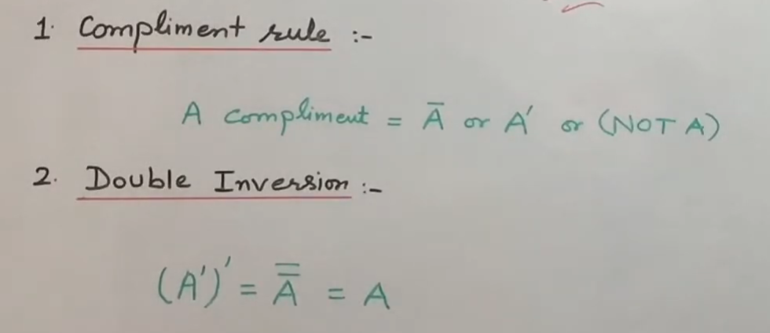
- AND Rules :-
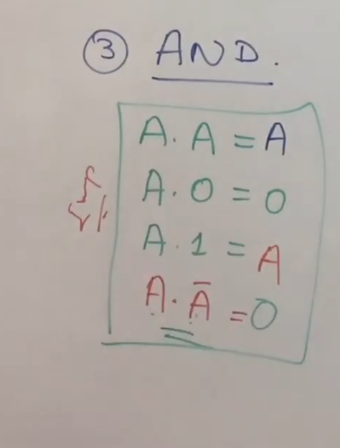
- OR Rules :-
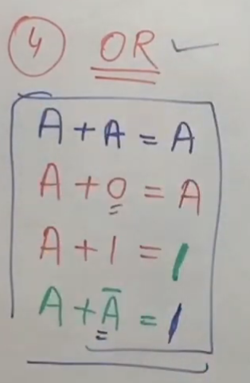

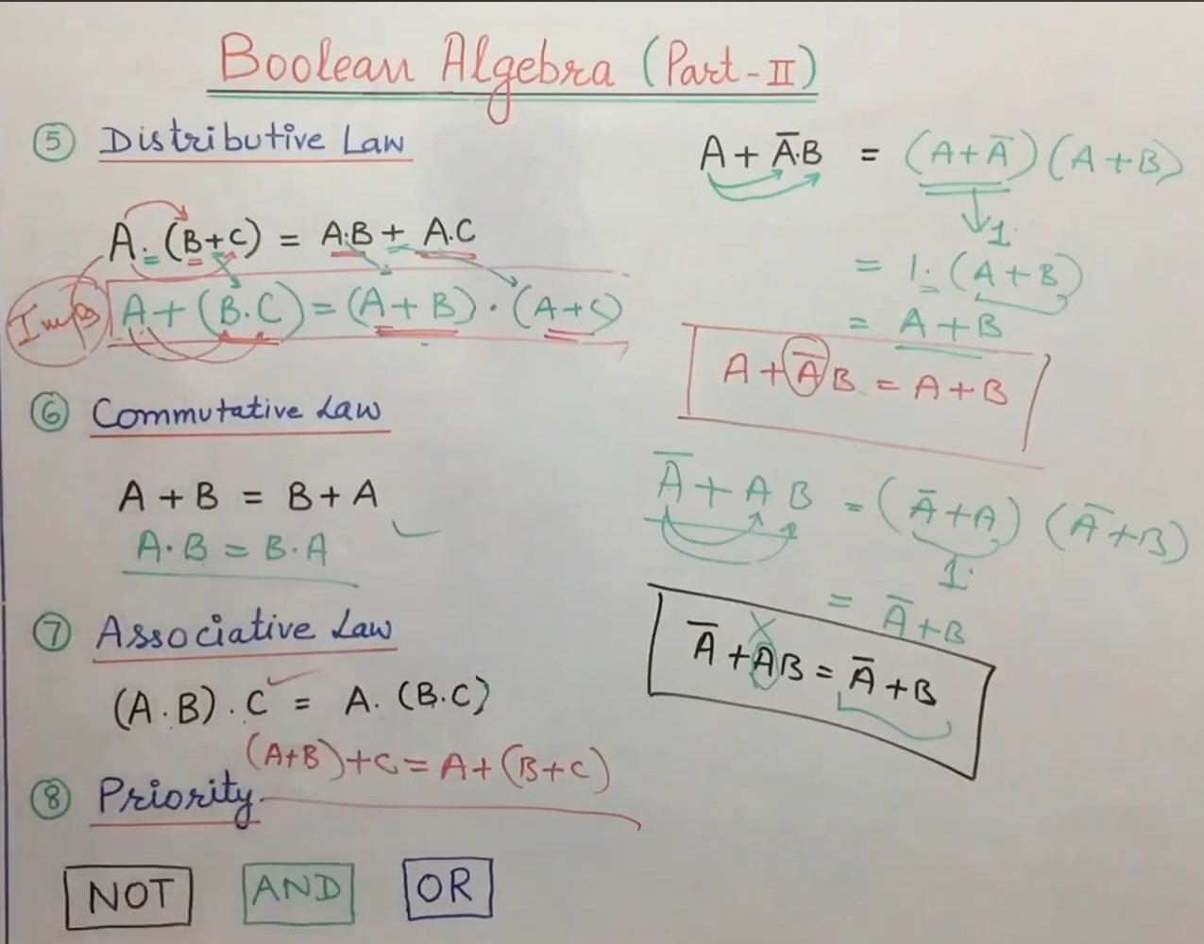

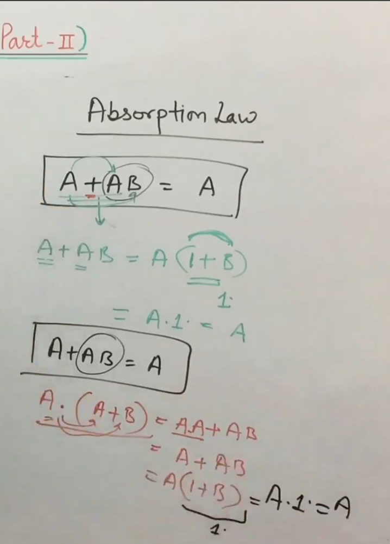

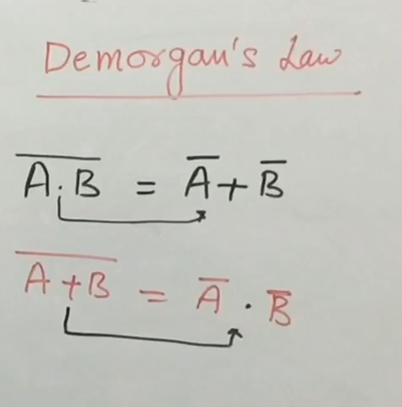

- Boolean Algebra Q.1:-
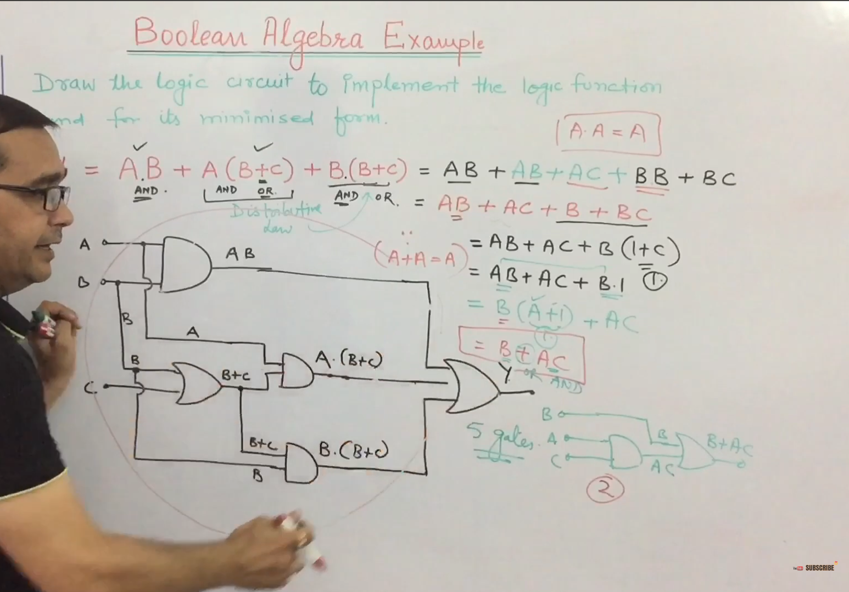

- Boolean Algebra Q.2:-
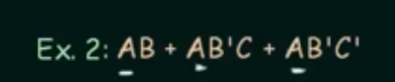

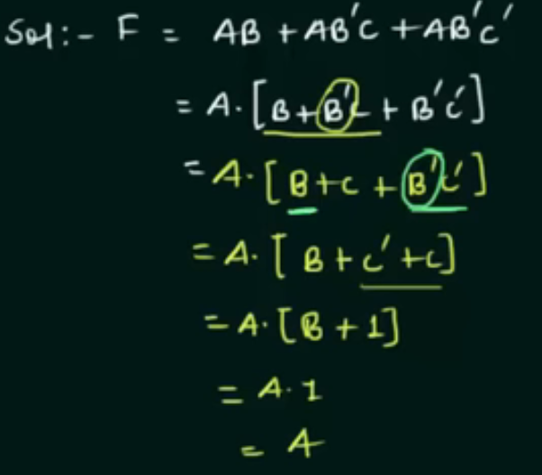
- Boolean Algebra Q.3:-
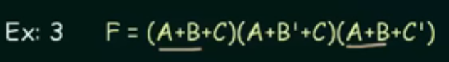

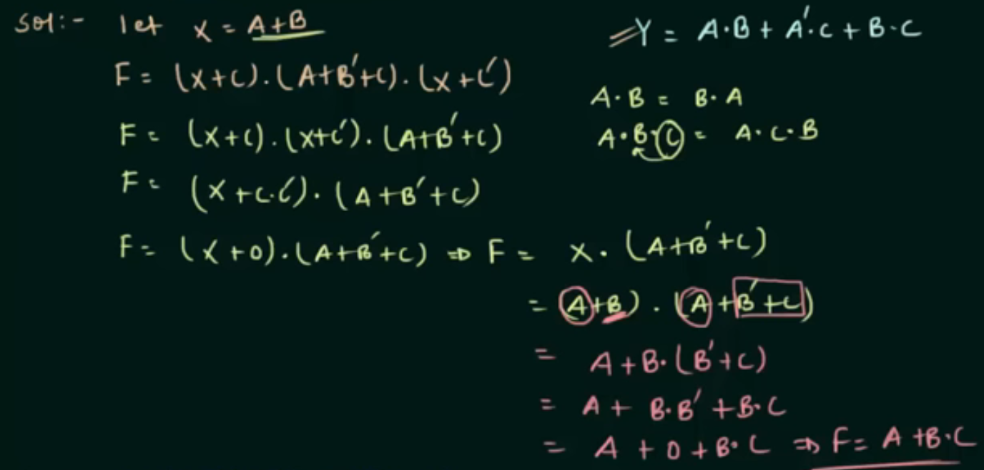

- Boolean Algebra Q.4 :-
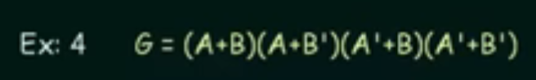

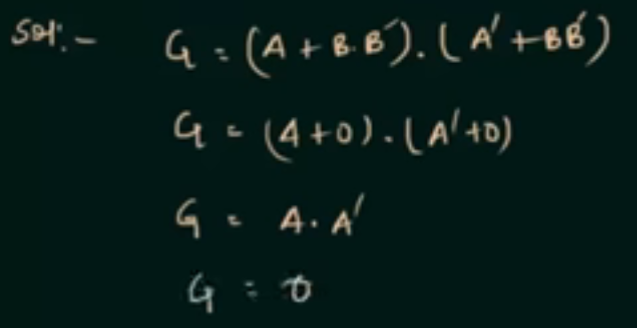

- Redundancy Theorem or Consensus Theorem in Boolean Algebra :-

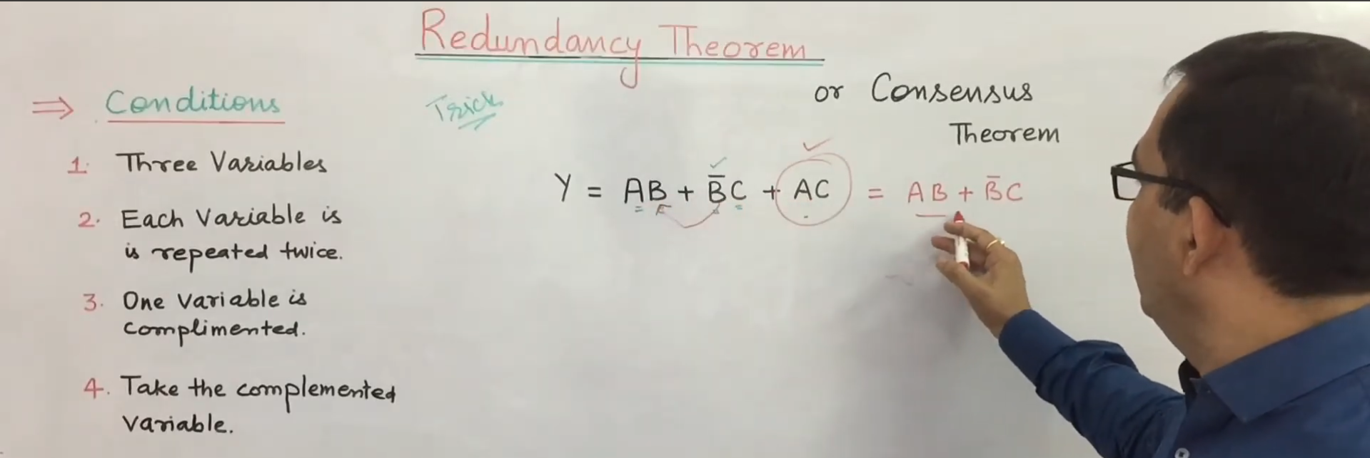

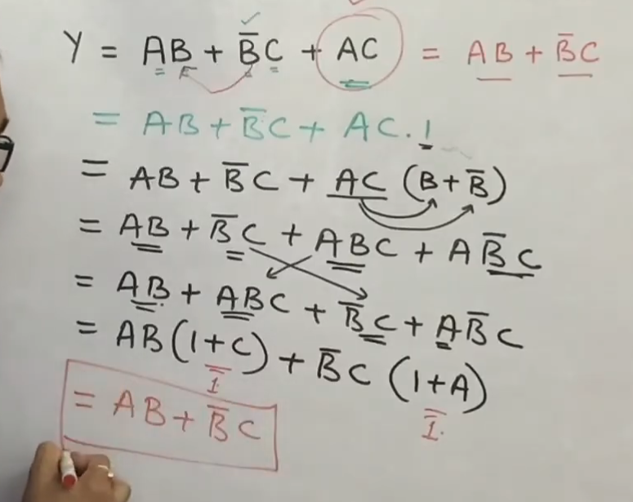
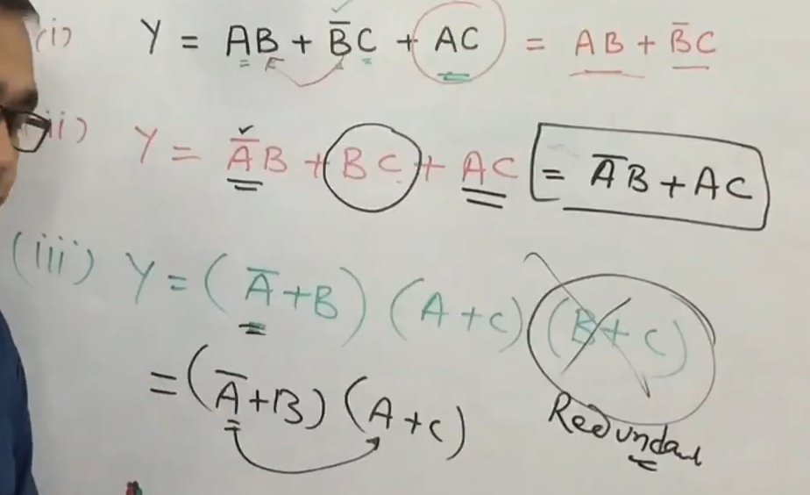

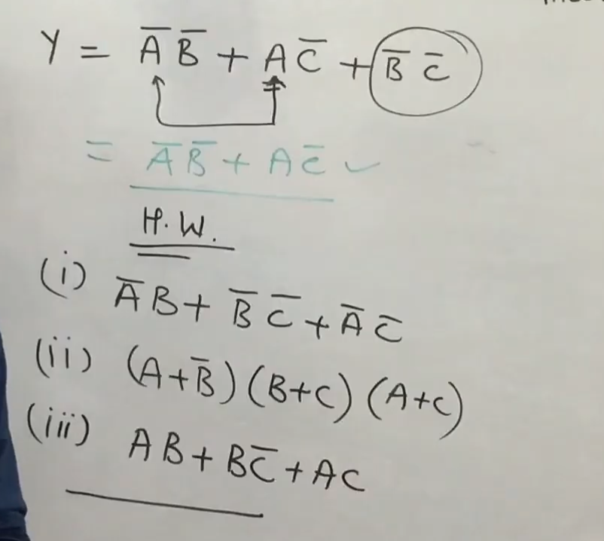

Ans.1 :- $\overline{A}B+ \overline{BC}$
Ans. 2 :- $\left(A+\overline{B}\right) ∙ (B+C)$
Ans. 3 :- $B\overline{C}+AC$

